Département des Langues Faculté des Sciences
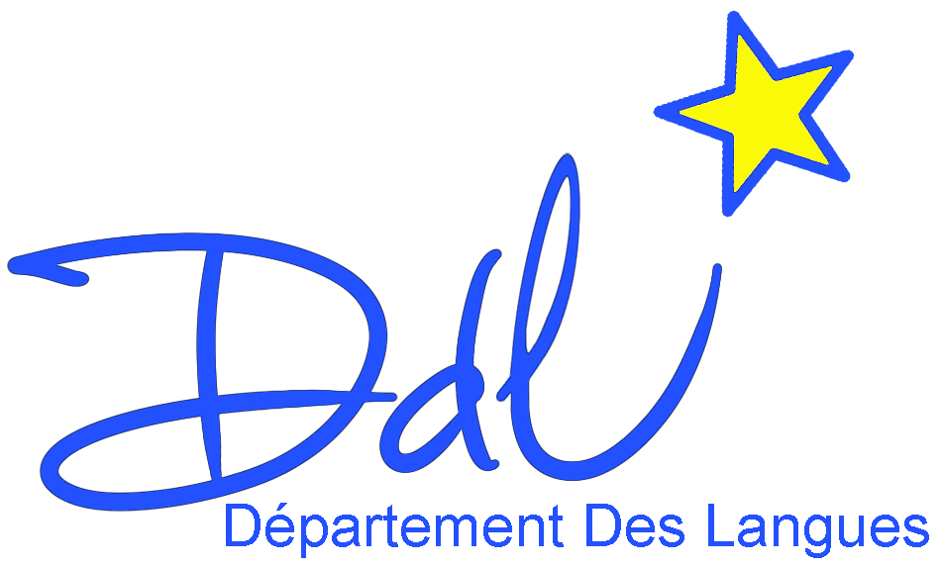 M1 INFO
English Listening & Academic Writing Test
Do NOT write in pencilI
Video 1 /10
You have watched the video once. Now read the questions and answer them as best you can. You will see the video 3 more times.
1. VNTANA (3)
a) What sort of company is it ? | Tech start up company
b) Where is it ? | based sea side of santa monica
c) What does it create ? | Holograms
d) Which sectors does it create for ? | i) Entertainment sector  ii) marketing sector  iii) education sector

3. Complete the blanks … (4) (0.5 each correct answer / remove 0.25 if ‘s’ absent)
The system allows live remote a) appearances and b) virtual concerts. It
is c) interactive and d) users can control the projected
e) images with f) gestures.
"It takes g) two people less than an hour to set up the h) screen, and it can be shipped anywhere in the world."
4. How are Silicon Valley and Silicon Beach said to be different ? (1) silicon valley oriented towards technology, silicon beach towards entertainment

5. The technology sector is diverse. Matthew Goldman is with Wallaby Financial…. What does this company do and how ? (2)

